Question 1: design decisions (2 marks)
(i) What is your admission number, and how did it determine your dataset (number of gigs, categories, and currency)?
My admission number is C027-01-0848/2024. The last digit (8) meant I created 13 gigs (5 + 8). Since 0848 is an even number, I used the categories Development, Design, and Writing. The first two digits are 08, which is less than 10, so I used KES as the currency.
(ii) Why did you choose to include the status field in your gig data model? What are the possible statuses and what do they represent?
I included the status field so that users can know the current progress of each gig. The possible statuses are Open, In Progress, and Closed

Question 2: Validation (2 marks)
(i)What validation rules did you apply to the budget field in your Pydantic model? Why is this validation important?
I validated the budget field by making sure it is greater than zero. This is important because a gig cannot have a negative or zero budget.
(ii) How did you ensure that the category field only accepts values from your assigned category list?
I used the Category enum to restrict the category values. This ensures that only Development, Design, or Writing can be entered.

Question 3: Error Handling (2 Marks)
(i) What status code does your API return when a user tries to retrieve a gig that does not exist? Explain why this is the appropriate status code.
The API returns 404 Not Found. This is the correct status code because the requested gig does not exist in the database.
(ii) What status code does your API return when a user tries to create a gig with invalid data? Explain why.
The API returns 422 Unprocessable Entity. This happens because FastAPI and Pydantic validate the input before creating the gig and reject invalid da

Question 4: Search and Filtering (2 Marks)
(i) Describe how your /gigs/search endpoint works. How does it handle searches where the query string does not match any gig?
The /gigs/search endpoint searches for gigs using the title. If no gig matches the search query, it returns a message saying that no gigs were found and an empty results list.
(ii) Describe how your /gigs endpoint with filtering works. What are the optional query parameters, and how do they work?
The /gigs endpoint allows filtering using category, min_budget , and max_budget. These parameters help users find gigs by category or within a specific budget range.

Question 5: Code Walkthrough (2 Marks)
(i) Write a brief explanation of the PUT /gigs/{gig_id} endpoint. What does it do, and how does it handle a request to update a gig that does not exist?
The PUT /gigs/{gig_id} endpoint updates the budget or status of an existing gig. If the gig ID is not found, the API returns 404 Not Found.
(ii) Write a brief explanation of the POST /gigs endpoint. What does it do, and how does it ensure that the new gig is created correctly?
The POST /gigs endpoint creates a new gig using the data entered by the user. It validates the input using the GigCreate model, assigns a new ID, sets the currency to KES, sets the status to Open, and then saves the gig.

This is the API link : http://127.0.0.1:8000/docs#/
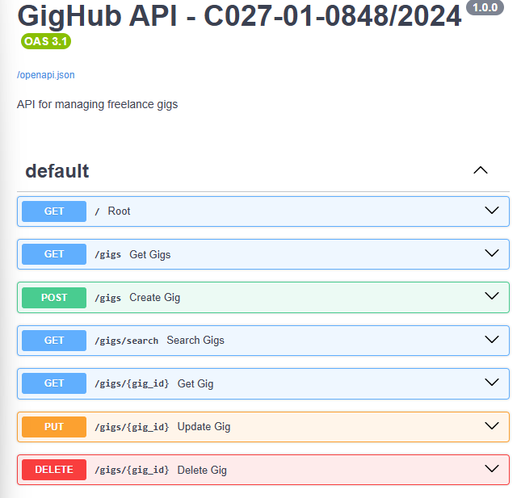
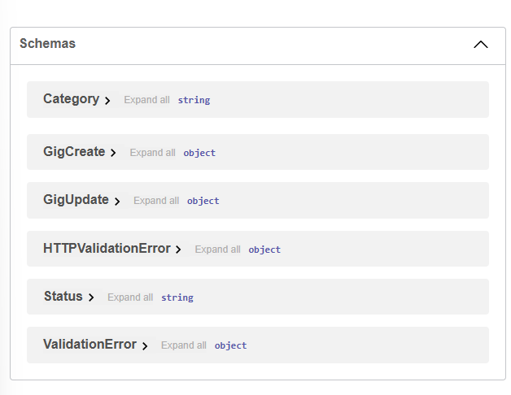

GitHub repository link : https://github.com/serianaiirene24-source/gighub-api

